

**Wireframe Document**

**ANALYZING AMAZON SALES DATA**

**Revision Number: 1.0**

**Last date of revision:19/11/2022**

**SOURAV DEY**

**Document Control**

|  |  |  |  |
| --- | --- | --- | --- |
| **Date Issued** | **Version** | **Description** | **Author** |
| 19th November 2022 | 1.0 | Complete version of Wireframe Document | Sourav Dey |
|  |  |  |  |
|  |  |  |  |

**We Performed Exploratory Data Analysis on Jupyter Notebook and then created a Power BI Desktop Dashboard.**

**1. What was the Sales of each Item?**

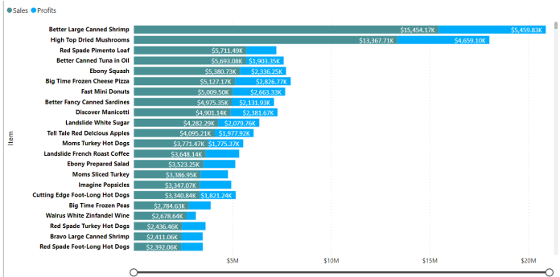

At $15,454,172.47, ‘Better Large Canned Shrimp’ had the highest Sales, followed by ‘High Top Dried Mushrooms’ which was around $13,367.71k and 3rd most sold product was ‘Red Spade Pimento Loaf’ Better Large Canned Shrimp accounted for 8.51% of Sales. Sales and Profits diverged the most when the Item was Better Large Canned Shrimp when Sales were $9,994,346.21 higher than Profits. Profits trended down, resulting in a 16.16% decrease between 2017 and 2019. Profits trended down, resulting in a 21.15% decrease between January 2017 and October 2019, it dropped from $9,598,696.65 to $7,568,565.85 during its steepest decline between January 2017 and October 2019.

**2. How was the growth in Profit year over year?**

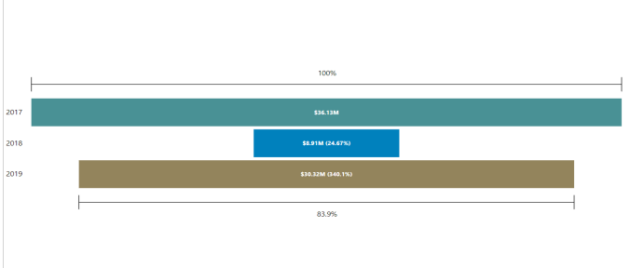

¬ In 2017 $36.13M Profit was generated, but in 2018 it severely declined to $8.91M which was only 24.7% of 2017’s Profit, then in 2019 it showed tremendous growth and was $30.32M which was 340.1% more than the previous value and 83.9% of 2017’s profit.

**3. How was the Sales & Profit Yearly-Quarter wise?**

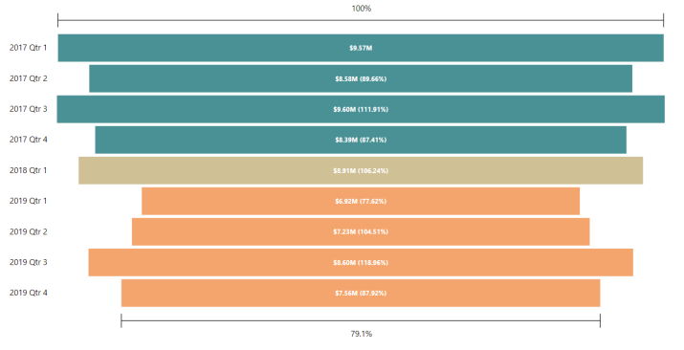

¬ In the first quarter of 2017, the profit was $9.57M. Then in the 2 nd quarter, it slightly declined by 11.34% to $8.58M which was only 89.66% of the previous value. Then in 3rd quarter, it was little improved to $9.60M which was 111.91% of the previous value. Then coming to the 4 th quarter of 2017, it was $8.39M. In the first quarter of 2018, it was $8.91M which was 106.24% of the previous value which means it was little improved by 6.24%. After that, it got significantly decreased by 22.38% from the 1st quarter of 2018 to 1st quarter of 2019 then after that, it started to improve as profit increased month by month and $1.68M more profit was collected compared to the profit of 1st quarter of 2019 which was $6.92M.

**4. Which items are the best-selling Item?**

¬ At $15,454,172.47, Better Large Canned Shrimp had the highest Sales and was 187.21% higher than Ebony Squash, which had the 5th Highest Sales at $5,380,727.75. Better Large Canned Shrimp accounted for 33.89% of Sales. Across all 5 Item, Sales ranged from $5,380,727.75 to $15,454,172.47.

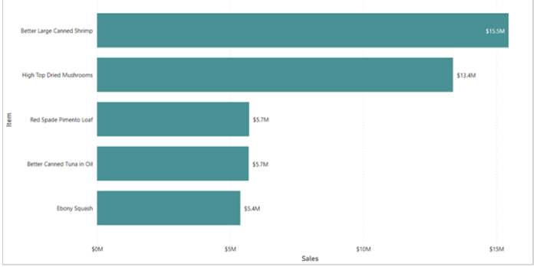

**5. Which Items generated Highest Profit?**

¬ At $5,459,826.26, Better Large Canned Shrimp had the highest Profits and was 129.24% higher than Discover Manicotti, which had the 5th highest Profits at $2,381,667.84. Better Large Canned Shrimp accounted for 30.35% of Profits. Across all 5 Item, Profits ranged from $2,381,667.84 to $5,459,826.26.

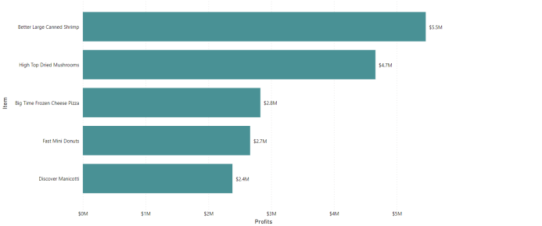

**6. Which Items generated the lowest profits?**

¬ At $327.06, BBB Best Corn Oil had the 5th lowest Sales and was 59.77% higher than Kiwi Lox, which had the lowest Sales at $204.71. BBB Best Corn Oil accounted for 26.16% of Sales. Across all 5 Items, Sales ranged from $204.71 to $327.06.

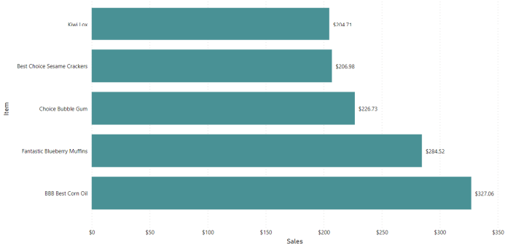

**7. What were the items that resulted in a loss?**

¬ At $4,026.61, Landslide Low Fat Apple Butter had the 5th Highest Loss and was 91.27% higher than Fast Lemon Cookies, which had the Highest Loss at $46,106.59.Fast Lemon Cookies accounted for 49.03% of Loss.Across all 5 Item, Loss ranged from ($46,106.59) to ($4,026.61).

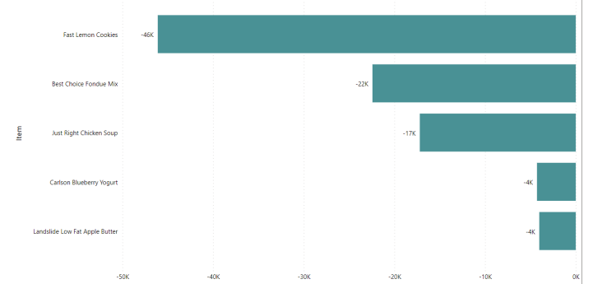

**8. Detailed Sales and Profits Analysis.**

¬ In this Decomposition Tree visual, we can Analyse how much Sales & Profits were made from 2017 to 2019. Comparing 3 Years, 2017 was the year in which highest Sales & Profits were made, which was $8,49,99,775.12, $3,61,34,835.97 and it was most made on Sunday, which was $2,60,58,258.91, $1,10,79,431.64. Sales & Profits were very balanced in all 4 Quarters but it was highest in Q3($79,18,281.76, $33,82,668.73). August was the month in which the highest Sales & Profits were recorded, which was $30,55,208.79, $13,00,021.88. In that Month Sales & Profits were generated on the 6th , 13th,20th, 27th .

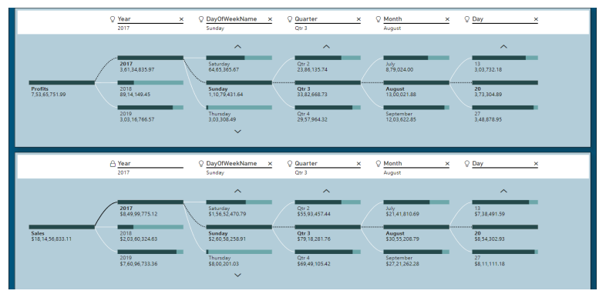

• At $1,13,97,206.36, 10021485 had generated highest Sales and was 383.63% higher than 10025241, which had the 5th highest Sales at $23,56,595.66. 10021485 accounted for 18.16% of Sales. Across all 10 CustKey, Sales ranged from $23,56,595.66 to $1,13,97,206.36.

• At $52,15,559.07, 10021485 had generated highest Profits and was 312.11% higher than 10019194, which had the 5th highest Profits at $12,65,561.04. Across all 10 CustKey, Profits ranged from $1265561.04 to $5215559.07.

**9. Comparing Sales for Q1, Q2, Q3 by Sales for Q2, Q3, Q4 of 2017 on which Day Sales Changed the most?**

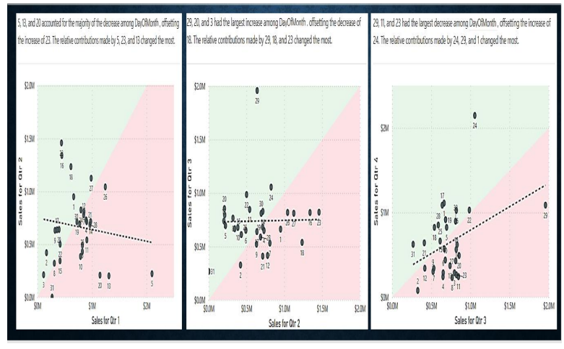

**10. Comparing Sales for January, February by Sales for February, March of 2018 on which weekday Sales Changed the most?**

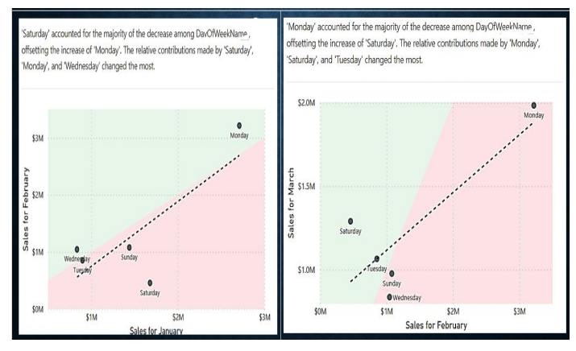

**11. Comparing Sales for Q1, Q2, Q3 by Sales for Q2, Q3, Q4 of 2019 on which Day Sales Changed the most?**

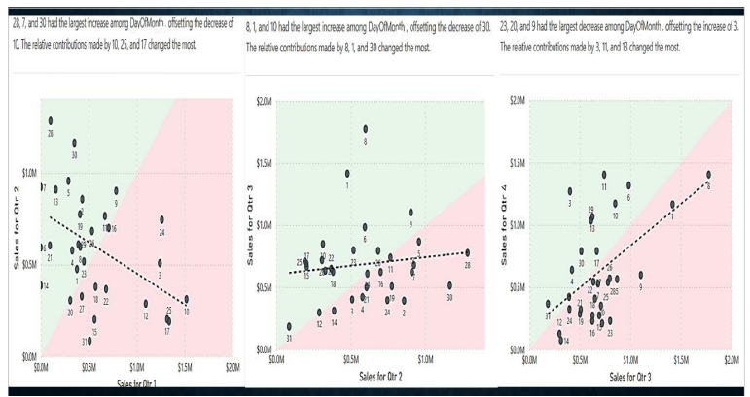

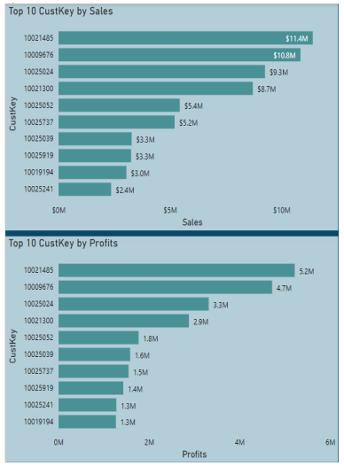**12. Who were the Top 10 Customers?** .• At $1,13,97,206.36, 10021485 had generated highest Sales and was 383.63% higher than 10025241, which had the 5th highest Sales at $23,56,595.66. 10021485 accounted for 18.16% of Sales. Across all 10 CustKey, Sales ranged from $23,56,595.66 to $1,13,97,206.36.

• At $52,15,559.07, 10021485 had generated highest Profits and was 312.11% higher than 10019194, which had the 5th highest Profits at $12,65,561.04. Across all 10 CustKey, Profits ranged from $1265561.04 to $5215559.07